**Build these 5 Projects to Get Better at Nextjs**

[[Mohit](https://medium.com/@mohit-vaswani?source=post_page-----498a2b76fde2--------------------------------)](https://medium.com/@mohit-vaswani?source=post_page-----498a2b76fde2--------------------------------)

[Mohit](https://medium.com/@mohit-vaswani?source=post_page-----498a2b76fde2--------------------------------)

·

Follow

3 min read

·

6 days ago

43

2

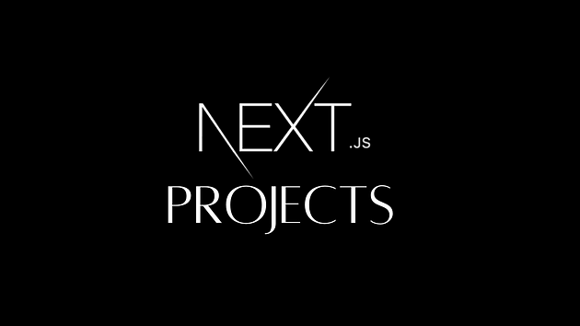

Next.js is an amazing framework for building React apps. It offers numerous benefits. Today, I would like to provide you with five Next.js projects that can help you learn how to create a fast and attractive web application using Next.js. These projects include live links and GitHub repositories for your convenience.

**1. A minimal portfolio template for Developers**

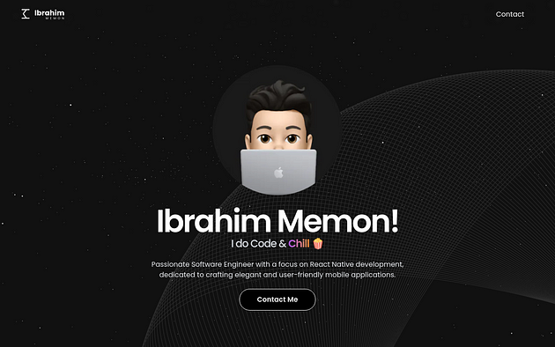

The whole [portfolio](https://developer-portfolio-jokpvaf4a-ibrahim-memons-projects.vercel.app/) is a React-based single page app built with Next.js in Typescript, using only statically generated pages. This project uses [next/font](https://nextjs.org/docs/basic-features/font-optimization) to automatically optimize and load Inter, a custom Google Font. All project images live under public/images and are automatically attached to each project based on the inclusion of the project’s slug in their filenames

[Github](https://github.com/ibrahimmemonn/Developer-Portfolio)

**2. A Real-time weather app built with Next.js 14, Typescript and Shadcn UI**

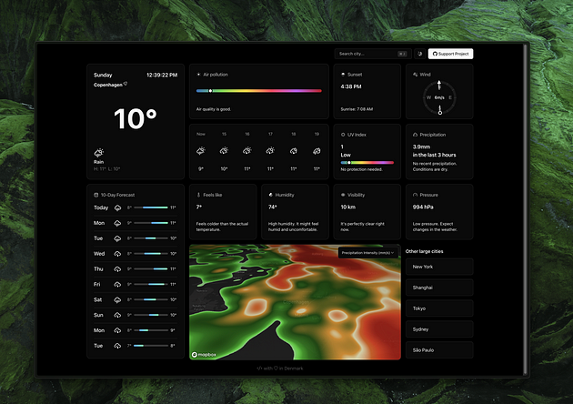

A meticulously crafted weather app that leverages cutting-edge technologies for a seamless weather experience. This app is powered by Next.js 14, TypeScript, Tailwind CSS, and the elegance of Shadcn UI library. It uses React Hotkeys Hook for smooth theme transitions and a versatile command menu. Additionally, it integrates React Map GL for Mapbox map integration and provides intelligent places autocomplete suggestions powered by Google Maps Places API.

[Github](https://github.com/DariusLukasukas/nextjs-weather-app)

**3. A video editor that runs in the browser, built with fabric.js and Next.js**

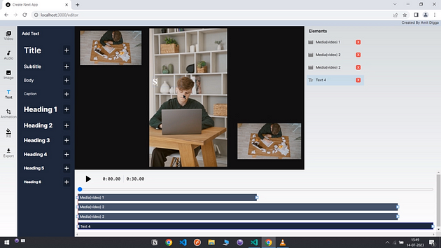

Fabric Video Editor is a video editor that runs in the browser. It is built with fabric.js, Next.js (a React framework), Tailwindcss, Mobx, and typescript. Inspired by invideo.io

[Github](https://github.com/AmitDigga/fabric-video-editor)

**4. A visual Deep Learning Framework for the Web, Built with WebGPU and Next.js**

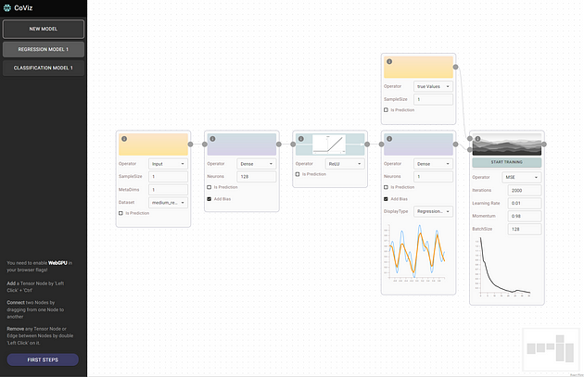

CoViz has a user interface that features a node editor powered by ReactFlow. This allows users to easily create a neural network computation graph. Users can choose from a variety of regression and classification tasks and datasets. They can then train their network to learn patterns in the data.

[Github](https://github.com/TilliFe/Neural-Network-Playground)

**5. A Personal AGI Application using GPT-4 and Nextjs**

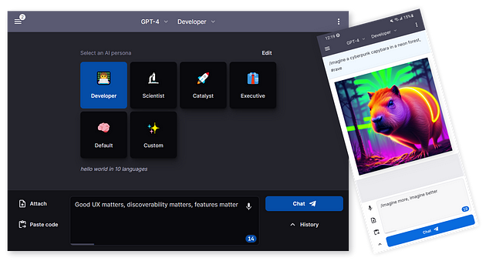

Introducing Big-AGI, a personal AGI app that goes above and beyond. Designed for smart humans and superheroes, this responsive web app comes with features like Personas, Drawing, Code Execution, PDF imports, Voice support, data Rendering, AGI functions, chats, and more. With Big-AGI, you can impress your friends with its amazing capabilities. Time to blast off! 🚀

[Github](https://github.com/enricoros/big-agi)

**Bonus:**[**Full-Stack SaaS Template to build your startup fast**](https://shipfa.st/?via=limitedoffer)

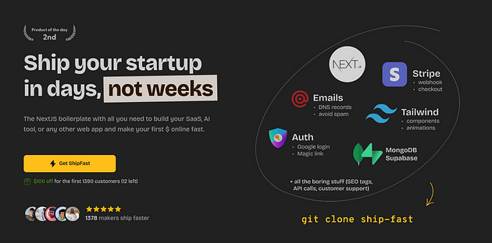

Thanks for reading. If you want more projects like this, please clap so that I can publish more.